PWWF Sponsorship Form
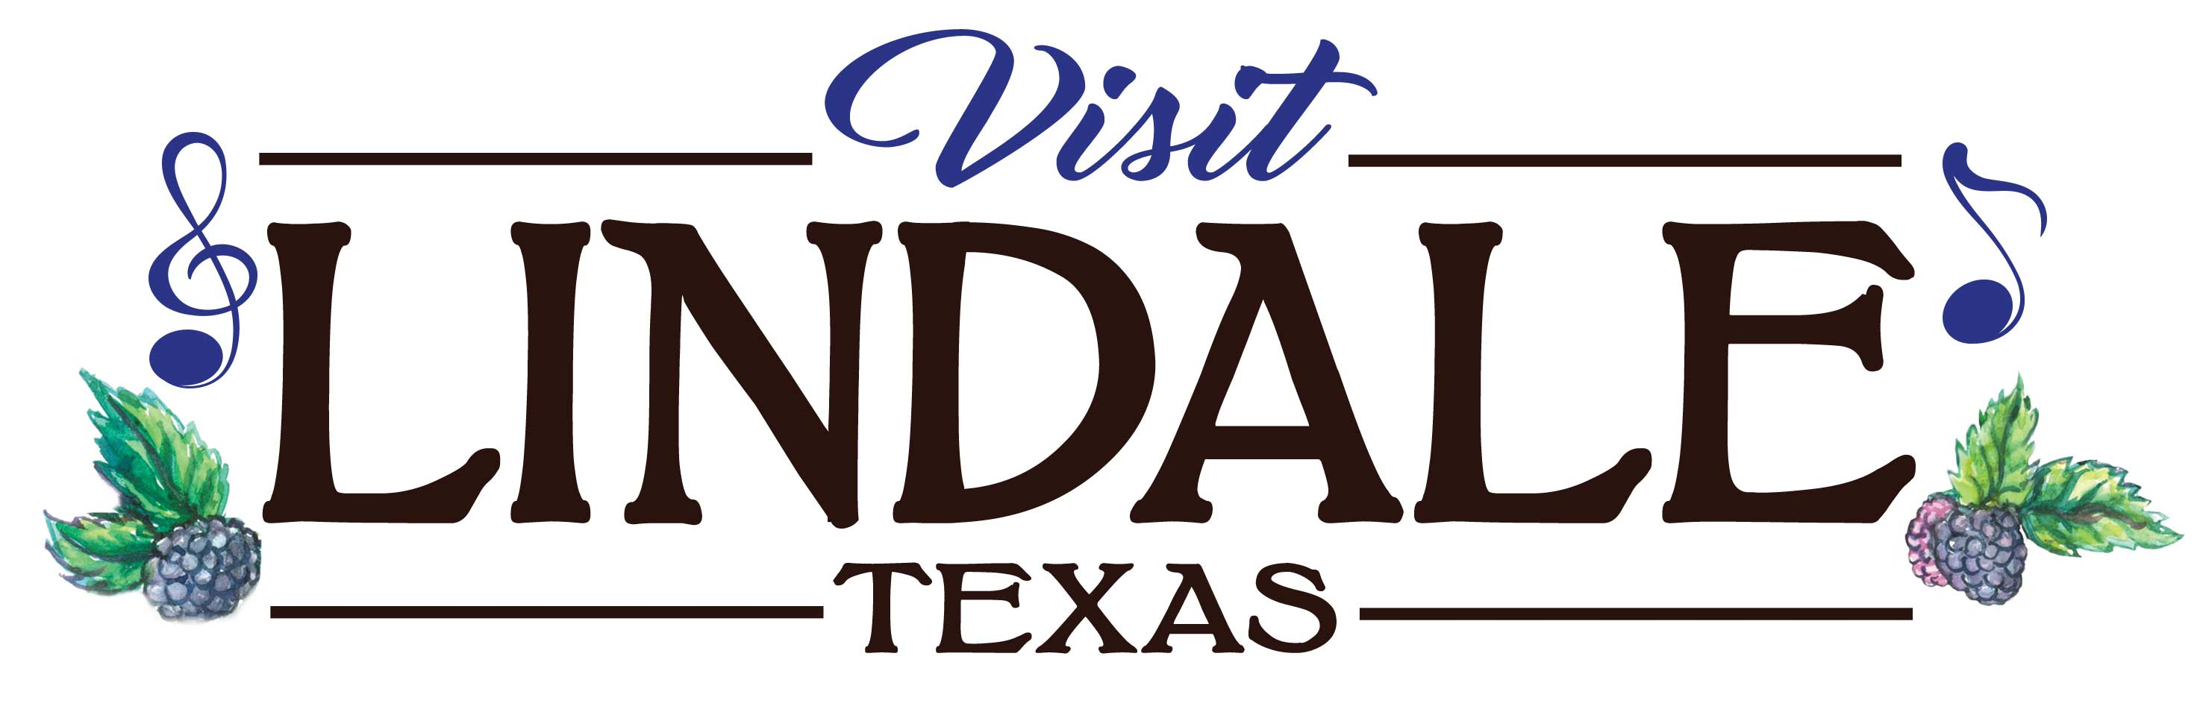 | City of Lindale Tourism Department  55 Miranda Lambert Way Suite 3 - Lindale, Texas 75771  903-881-5103 OR seongm@lindaletx.gov (903)617-9132

SPONSOR INFORMATION

Name

Billing address

City, ST, Zip Code

Phone 1 | Phone 2

Fax | Email

Sponsorship Information
I (we) sponsor a total of $____________________.
I (we) plan to make this sponsorship in the form of: ☐cash ☐check ☐credit card ☐other.

Credit card type | Exp. date

Credit card number

Authorized signature

SPONSORED EVENT/FESTIVAL
Event/Festival Name: | PINEY WOODS WINE FESTIVAL 2020
Location: | PICKER’S PAVILION – 205 E. NORTH STREET
City, ST, Zip Code | LINDALE, TEXAS 75771
Date of Event: | MAY 8TH, 5PM – 9PM & MAY 9TH, 11AM – 7PM
Purpose of Event: | WINE FESTIVAL

Acknowledgement Information (please email high res logo)
Please use the following name(s) in all acknowledgements:

☐I (we) wish to have our sponsorship to remain anonymous.
Signature(s) |  | Date
Please make checks payable to: |  | City of Lindale  55 Miranda Lambert Way Suite 3  Lindale, Texas 75771
Cabernet Sauvignon Sponsor $5,000
- 2 Banners (minimum 3'x5', maximum 4'x8') outside on Festival Grounds, 1 Banner inside Picker's Pavilion
- Live hourly Stage Mentions
- Friday, May 10, 2019 - 1 VIP Table - Premium Position (10 Seats) including 10 Wine Totes, 10-9 oz. Stemless Wine Glasses and 10 VIP Wristbands
- Saturday, May 11, 2019 - 1 VIP Table - Premium Position (10 Seats) including 10 Wine Totes, 10-9 oz. Stemless Wine Glasses and 10 VIP Wristbands
- Inclusion on television, radio, social media, billboard and print advertising
- Logo and link on VisitLindale website
- Premium 10 x 10 space for sponsorship activation during the festival (client provides tent)
Merlot Sponsor $2,500
- 1 Banner (minimum 3'x5', maximum 4'x8') outside on Festival Grounds, 1 Banner inside Picker's Pavilion
- Saturday, May 11, 2019 - 1 VIP Table - Premium Position (10 Seats) including 10 Wine Totes, 10-9 oz. Stemless Wine Glasses, 10 VIP Wristbands, and two bottles of wine
- Inclusion on all social media, and print advertising
- Logo and link on VisitLindale website
Chardonnay Sponsor $1,000
- 1 Banner (minimum 3'x5', maximum 4'x8') outside on Festival Grounds
- Saturday, May 11, 2019 - 1 VIP Table - Premium Position (10 Seats) including 10 Wine Totes, 10-9 oz. Stemless Wine Glasses, 10 VIP Wristbands, and one bottle of wine
- Inclusion on all social media
Zinfandel Sponsor $500
- 1 Banner (minimum 3'x5', maximum 4'x8') outside on Festival Grounds
- 4 Wine totes, 4-9 oz. stemless wine glasses, 4 Wristbands and one bottle of wine

